ITUE203: WEB DEVELOPMENT FRAMEWORKS 25CS106– Yana


Faculty of Technology and Engineering

Chandubhai S. Patel Institute of Technology (CSPIT) Department of Computer Science & Engineering

Laboratory manual
Academic Year | : | 2026-27 | Semester | : | 3rd

Practical - 12

PROBLEM STATEMENT :
Develop event management functionality for admin users. Admin can add, view, update, delete, and upload event posters with file type and file size
validation.
OBJECTIVE:
To develop an admin-based event management module using PHP and MySQL that allows administrators to add, view, update, and delete event records and upload event posters with proper file type and file size validation.
OUTPUT:
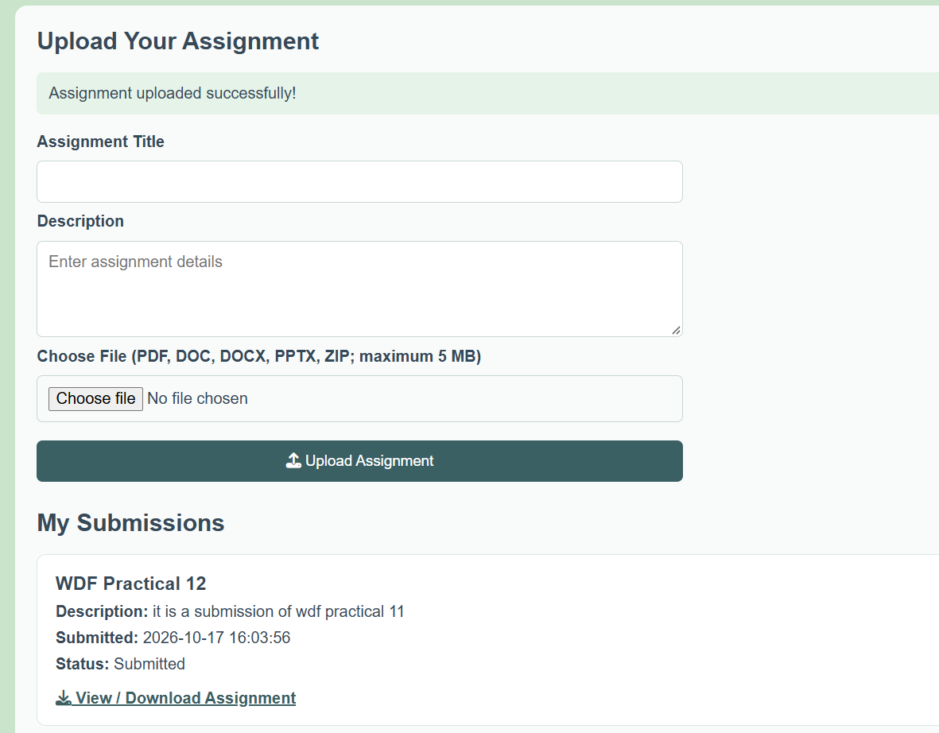
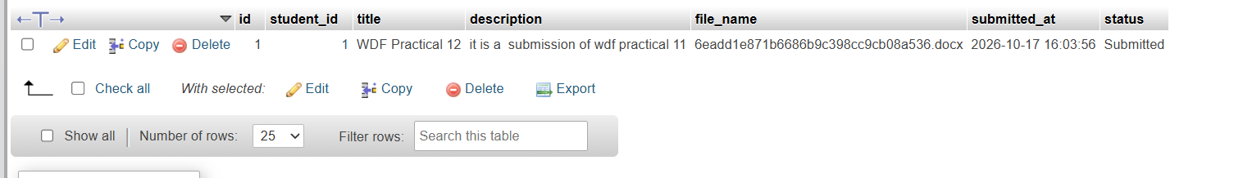
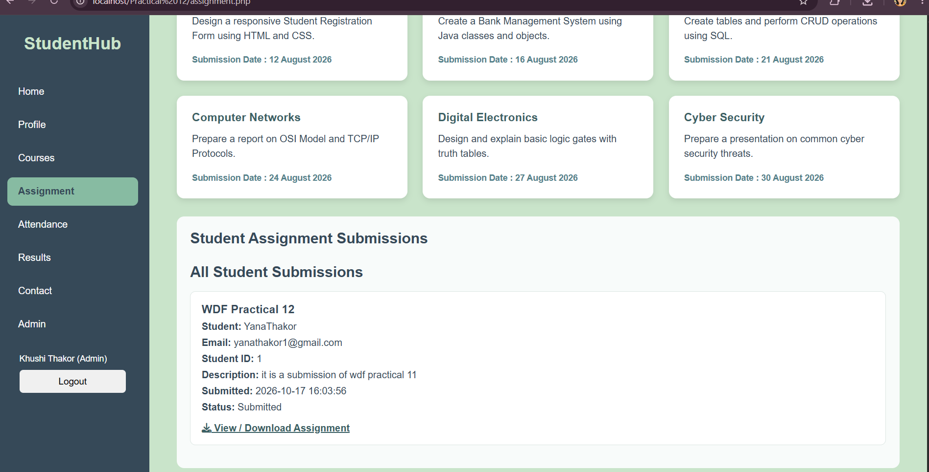

LEARNING OUTCOME:
• Understand and implement CRUD operations for event management using PHP and MySQL.
• Develop an admin interface to manage event details securely.
• Implement event poster uploads with file type and file size validation.
• Handle file uploads, database operations, and success or failure messages effectively.
• Apply server-side validation and access control to ensure that only authorized administrators can manage events.

